Ministry of Education, Culture and Research of the Republic of Moldova

Technical University of Moldova

FCIM, Department of Microelectronics

**REPORT**

*Electronics*

Laboratory work no. 3

**Topic**

*Study of the semiconductor diodes*

**Performed by:** Terman Emil

st. gr. FAF-161

**Verified by:** Lupan O.

Prof. dr. hab.

(02.11.2017)

Chişinău - 2017

**Study of the semiconductor diodes**

**The purpose of the work:**

Study of the functionality and base properties of the semiconductors diodes, rectifiers, impulse stabilizers, LEDs.

**The scheme:**

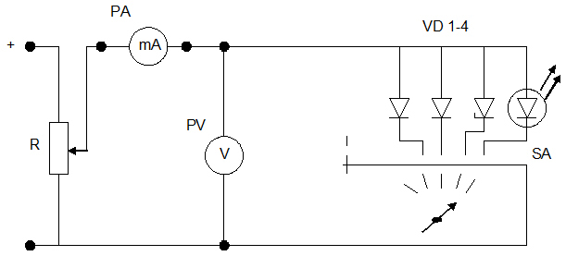

*Fig.1 (VAC at forward biased)*

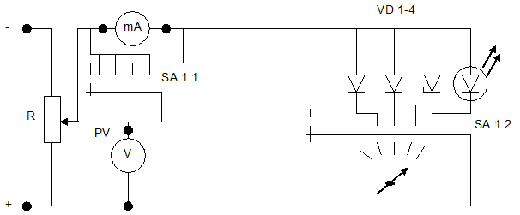

*Fig.2 (VAC at reverse biased)*

***Calculation steps:***

1. Assembly the scheme from fig.1. To the circuit is applied a DC source and is adjusted by a potentiometer R. With the switch SA the desired diode is switched to the circuit. The measurement devices are on the stand.

2. Take down and construct the volt-ampere characteristics values from the diodes *I=f (U)* from the scheme from fig. 1. Results are introduced in the table. Using the obtained values find out differential resistance *Rdnn=ΔUforward/ΔI* and the current when the LED is illuminating.

*Computation and determination table:*

*Forward biased:*

|  |  |  |  |  |  |  |  |  |  |  |  |  |  |  |  |  |  |  |  |  |  |  |  |  |  |  |  |  |  |
| --- | --- | --- | --- | --- | --- | --- | --- | --- | --- | --- | --- | --- | --- | --- | --- | --- | --- | --- | --- | --- | --- | --- | --- | --- | --- | --- | --- | --- | --- |
| ***U, V*** | | **0** | | **0.05** | | **0.1** | | **0.15** | | **0.20** | | **0.25** | | **0.3** | | **0.50** | | **0.6** | | **0.65** | | **0.7** | | **0.72** | | **0.75** | | **0.8** | |
| **I, mA** | **VD1** | | 0 | | 0.0035 | | 0.03 | | 0.14 | | 0.67 | | 4.80 | | - | | - | | - | | - | | - | | - | | - | | - |
| **VD2** | | 0 | | - | | - | | - | | 0.0002 | | 0.0008 | | 0.0018 | | 0.1 | | 0.78 | | 2.3 | | 6.79 | | 8.80 | | - | | - |
| **VD3** | | 0 | | - | | - | | - | | - | |  | | 0 | | 0.0002 | | 0.01 | | 0.04 | | 0.33 | | 0.83 | | 2.33 | | 8.72 |

|  |  |  |  |  |  |  |  |  |  |  |  |  |
| --- | --- | --- | --- | --- | --- | --- | --- | --- | --- | --- | --- | --- |
| ***U,V*** | | **0** | **1** | **1.25** | **1.4** | **1.5** | **1.6** | **1.7** | **1.8** | **1.85** | | **1.9** |
| **I, mA** | **LED** | 0 | 0.0001 | 0.0001 | 0.0002 | 0.0012 | 0.009 | 0.16 | 1.20 | | 2.88 | 5.90 |

*Reverse biased:*

|  |  |  |  |  |  |  |  |  |  |  |
| --- | --- | --- | --- | --- | --- | --- | --- | --- | --- | --- |
| ***Ui, V*** | | **0** | **1** | **2** | **3** | **4** | **5** | **7.4** | **7.45** | **7.5** |
| **I, µA** | **VD1** | 0 | 1.6 | 1.91 | 2 | 2.1 | 2.3 | - | - | - |
| **VD2** | 0 | 0 | 0.1 | 0.2 | 0.3 | 0.4 | - | - | - |
| **VD3** | 0 | 0 | 0.1 | 0.2 | 0.3 | 0.4 | 3 | 10 | 15.6 |

***Volt-ampere characteristics:***

Because *VC1 = 0.22 V*, the diode **VD1** is made of **Ge**;

*VC2=0.62 V* – the diode **VD2** is made of **Si;**

*VC3=0.64 V* – the diode **VD3** is made of **Si;**

*VCLED = 1.51 V* – the diode **LED** is made of **GaAs or AlGaAs**

**The main parameters:**

*Forward biased:*

$R_{1fw}=\frac{∆U_{1fw}}{∆I_{1fw}}=\frac{0.25−0.2}{\left(4.8−0.67\right)∙{10}^{−3}}=12\left(Ω\right)$

$R_{2fw}=\frac{∆U_{2fw}}{∆I_{2fw}}=\frac{0.72−0.7}{\left(8.8−6.79\right)∙{10}^{−3}}=9.9\left(Ω\right)$

$R_{3fw}=\frac{∆U_{3fw}}{∆I_{3fw}}=\frac{0.8−0.75}{\left(8.72−2.33\right)∙{10}^{−3}}=7.8\left(Ω\right)$

$R_{LEDfw}=\frac{∆U_{LEDfw}}{∆I_{LEDfw}}=\frac{1.9−1.85}{\left(5.9−2.88\right)∙{10}^{−3}}=16\left(Ω\right)$

***Reverse biased:***

$R_{zenerrw}=\frac{∆U_{zenerrw}}{∆I_{zenerrw}}=\frac{7.5−7.45}{\left(15.6−10\right)∙{10}^{−3}}=8.9\left(Ω\right)$

**Conclusion:**

During this laboratory work, we learned the main characteristics of the semiconductors, diodes and also with volt-ampere characteristics*: I=f(U);*

After doing this laboratory work, we can say the following:

* At direct polarization VAC represents a exponent; .
* At reverse polarization, the current (called saturation current) is extremely small (for Ge is of some tens of microamperes, for Si much less). This parameter is ideal for rectifying the alternating current. Also, tunnel-diodes have a very small reverse breakdown voltage, which can serve as an efficient element for voltage stabilizers.
* One of the key advantages of LED-based lighting sources is high luminous efficacy. White LEDs quickly matched and overtook the efficacy of standard incandescent lighting systems.
* Zener diodes are widely used as voltage references and as shunt regulators to regulate the voltage across small circuits.
* **The semiconductor diode is a very important element of electronics, because it offers a series of extremely useful characteristics: low threshold voltage, one-direction conductibility, stabilizing functions for Zener diodes, etc.**